How to Install and Configure BloodHound on Kali Linux
22 January 2021
Kali Linux
In our this article we are going to learn how to install BloodHound on our Kali Linux system. BloodHound is going to be extremely useful when we're looking to enumerate an active directory environment. It is very important tool for both Red-Team and Blue-Team.
This application developed with one purpose: to find relationships within an Active Directory (AD) domain to discover attack paths. BloodHound uses graph-theory so it is easy to find the shortest path for an attacker.

BloodHound identifies the attack paths in an corporate network that can be exploited for a pen tester (or a red team) to be able to gain domain admin permissions.

Install BloodHound on Kali Linux
BloodHound is now available on Kali Linux repository. To install BloodHound on Kali Linux first we need to install it from Kali Linux repository by using following command:
sudo apt-get install bloodhound
It will take some time to download and install depending on our internet speed and system performance.

Configure BloodHound on Kali Linux
We can't just install it and run bLoodHound. We need to configure it before running. First of all we need to set the permission by using following command:
sudo chown -R kali /usr/share/neo4j
Then we run the neo4j console by using following command:
neo4j console
Then the console will start as we can see in the following screenshot:
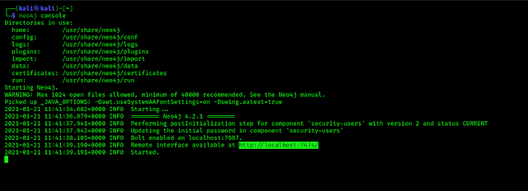
Localhost link is highlighted
We can see it is started and we can see the web interface is available on the highlighted localhost link. We need to navigate to the link first from our browser and we got the web interface as following screenshot:
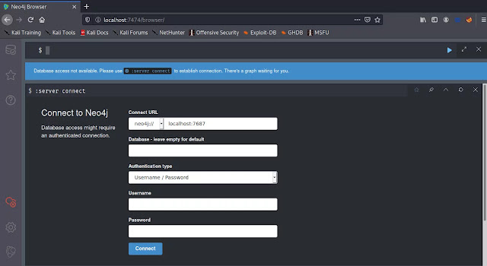
Here we need to create a new username and password, with the default password BloodHound will not open. Before that we need to login this web based interface using default password.
The default credential for BloodHound will be Username: neo4j Password: neo4j
We need to log in using the default credential and leave the other fields as it is. After login we can see fields to reset the default password as following screenshot:
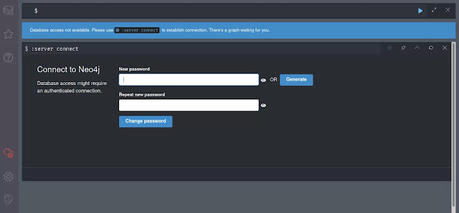
Here, we can choose a new password and repeat the password to confirm. It will create a new password for user neo4j. We can see it on the following screenshot:
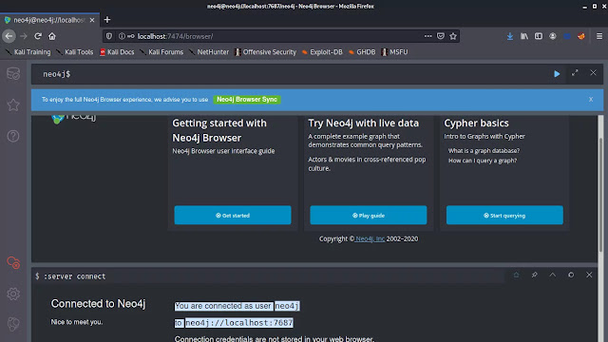
In the above screenshot we can see that we have changed the password for the user neo4j on bloodhound web interface, now it's time to open the BloodHound.

Running BloodHound on Kali Linux
We leave the the terminal running the neo4j console as it is, and open another terminal and run following command to start BloodHound:
bloodhound
This will open the BloodHound login panel as the following screenshot:
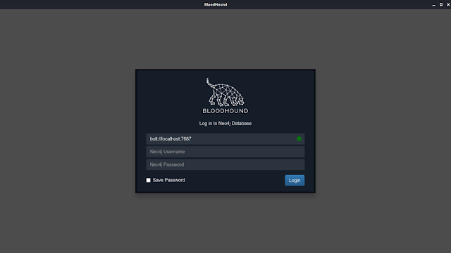
Here we need to confirm the green ✅ sign on the first field. Then we can login using username neo4j and the password we have chosen in previous step. After click on login we will be in the main screen of BloodHound as following screenshot:
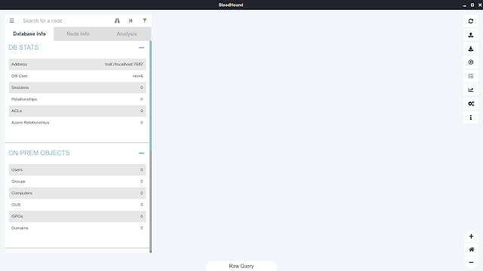
This is how to install BloodHound on Kali Linux.

Bloodhound working

powershell -ep bypass
./ADRecon.ps1 -outputDir All -ADRecon -Output Type HTML

import-module .\Sharphound.ps1
Invoke bloodhound -Collection Method All -Verbose -Domain pentesting

You can confirm the the info by using powerview for all acl
Get-ObjectAcl – Sam AccountName Hidden

What if we want to check AD Ridghts or Generic Write permission

Get -ObjectAcl -SamAccountName Hidden | ? {$_.ActiveDirectoryRigths -match ‘Generic Write’)}

let us say we verified that we have generic write access , now what we can do

net user student1 /domain

Add-Domain Group Member – Identify ‘Hidden’ -Members ‘student1’ -Domain ‘pentesting’

net user student1 /domain

Get-DomainGroup -Name hidden

I am running version 4.0.7. Many answers I found on the internet state "Delete /data/dbms/auth". That does not work for 4.0.7, that file does not exist.
I followed these instructions, and they worked. https://neo4j.com/docs/operations-manual/current/configuration/password-and-user-recovery/
Mainly do this:
- Stop neo4j if its running
- edit /etc/neo4j/neo4j.conf, and uncomment dbms.security.auth_enabled=false
- connect to the database and run
ALTER USER neo4j SET PASSWORD 'mynewpass'; :exit
- Stop neo4j
- comment out the dbms.security.auth_enabled=false
- start neo4j

If you want to send sharphound then send the one having same version as that of bloodhound you are running

usr/lib/bloodhound/resources/app/collectors

sharphound.exe located there

